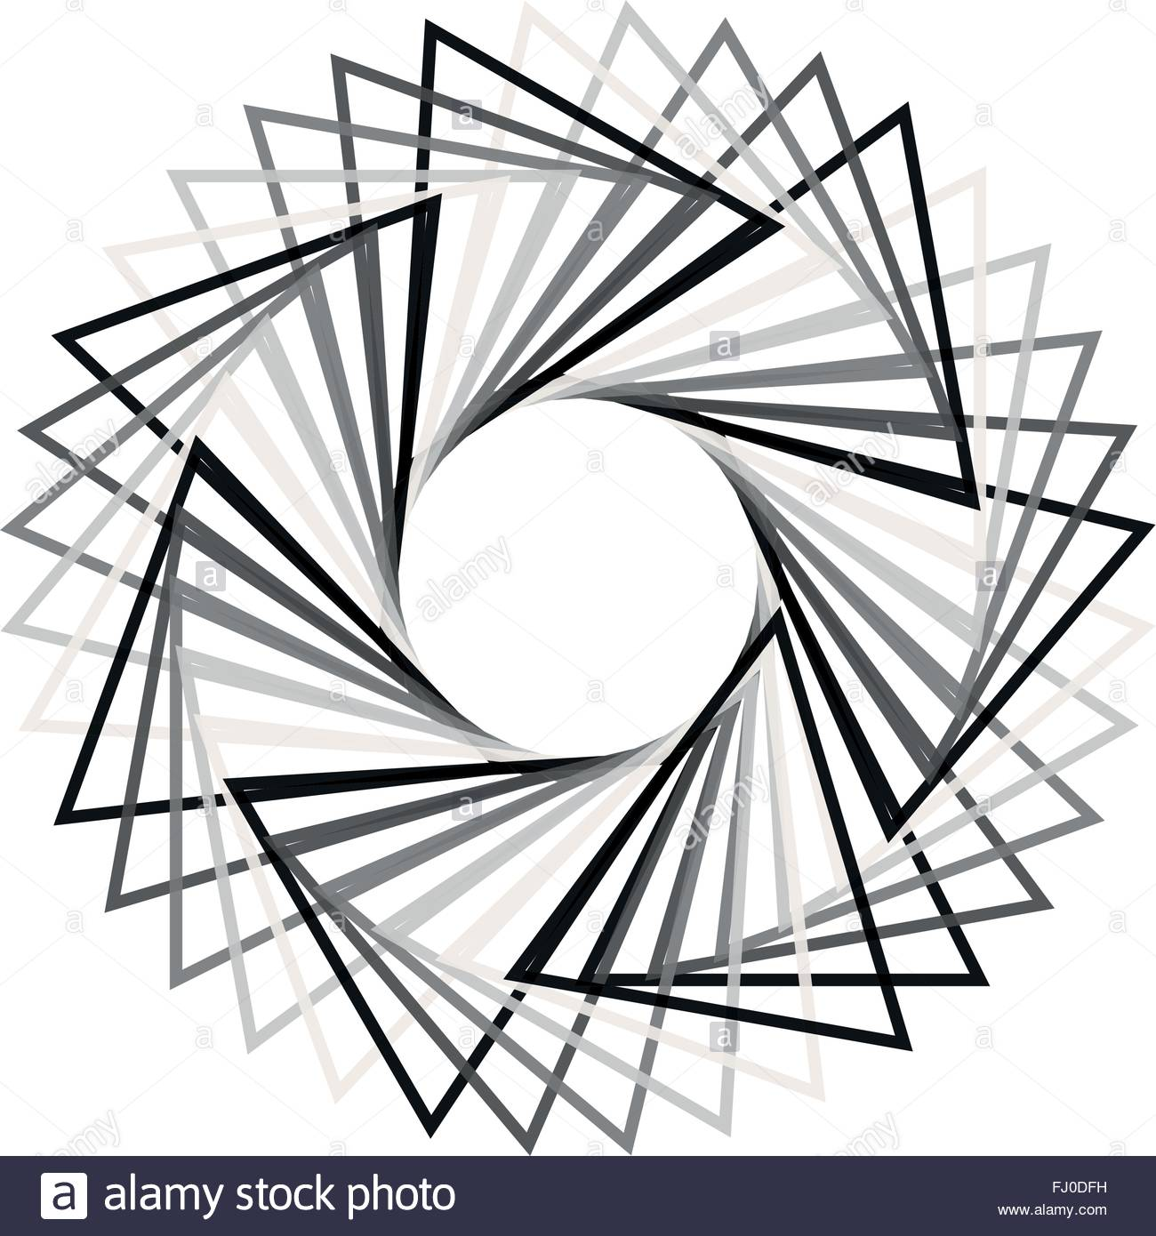

**Everboxing**

Design by Anthony Goh, Capstone Games

6/29/18

For PC

Ages: 12 and Up

Ship date: TBD

**A single player puzzle game that involves changing directions, layers, and structure of ever concentric shapes.**

**Story Summary: Everboxing** is a puzzle platform adventure game with a subtle story in the background. Players take the roll of Whisper, a young adventurer who has found their way into a massive mine that drives deep into the ground, while searching for treasure. As Whisper started to explore the mine he found himself into a trap. This trap teleports him deep within an ever boxed in world, causing him to stuck deep within many many layers of traps. He’ll have to find his way out of the trap, all the while meeting a cast of characters that will show him more information on who, why, and what this trapworld is and what it means to be part of it.

**Game Flow Outline: Everboxing** will start simple, moving from a few concentric boxes that all it requires is a few rotations of the boxes to help get Whisper out of the puzzle. They will become more difficult as time goes on building on concepts and powers gained. Powers will include the ability to change the direction of gravity, blast walls open, open locks, deal with fluids that will obey gravity as the shapes rotate around. Whisper will always be in the center of the screen, and the boxes will rotate around their center point, keeping Whisper there. Whisper follows gravity, falling down (unless gravity has been changed) when openings are below him. Every time Whisper gets out of the a set of boxes he finds himself in a safe area – a small settlement. Various characters that he meets inside the boxes will be released by him to start to show up in the safe area. Another set opens that he has to dive into to see if that will be the way out. Town will mostly be an area for story, but it will also allow the purchase abilities

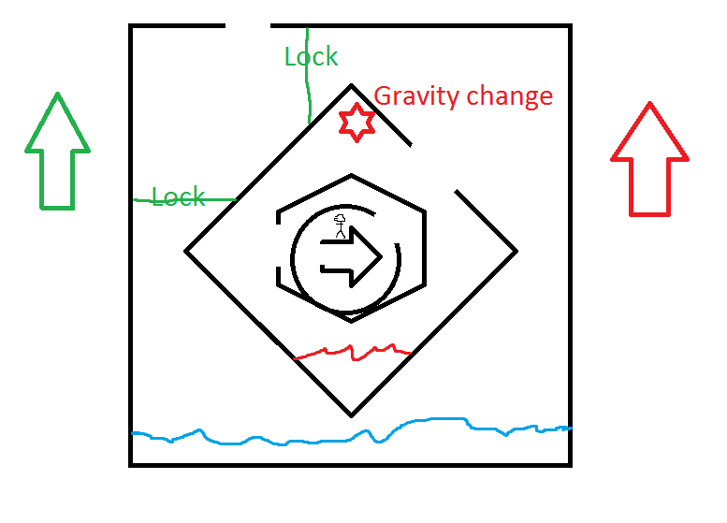

**Character:** Whisper is an adventurer, a person who loves to find treasure and find new places to explore. This time the curiosity may have killed the cat (but satisfaction will certainly bring him back again). Whisper is a kind soul, who generally wants to help people – his dialogue reflects that. However, he is not about being cold – or learning that in order to survive, he may have to be cold and thoughtless. These are decisions that the players may have to make as they control the world around Whisper to help him escape – will they turn him into a cold, heartless survivor, or will they try and ensure his good nature and kind heart survive this strange trap?

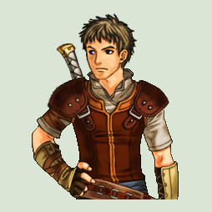

**Controls:** These simple controls are the majority of what is needed. They can be clicked on or they can be assigned to various keys

**Left Up Arrow:** This arrow rotates the world clockwise around Whisper by 36degrees.

(W, Up Arrow, NumPad8)

**Right Up Arrow:** This arrow rotates the world counterclockwise around Whisper by 36degrees

(S, Down Arrow, NumPad2)

**Jump:** This button, not introduced for several levels, allows Whisper to jump over obsticles while the world is turning. It must be hit at the right time or Whisper will bounce off and the rotation will slide back to where it was before

(Space, NumPad0, LftCtrl

**Power Button:** This button is a changeable button that rotates through the powers that Whisper has accumulated from various rescued people in the trap.

(Q or E, Left or Right Arrow, Numpad4 or 6)

**Gameplay:** **Everboxing** Is a rotation platform puzzler. The goal is to help the character escape from within the center of several concentric boxes of varying shapes by rotating them clockwise or counter clockwise. Within the boxes are various openings – these openings are how the avatar progresses further out, and then later back into the concentric boxes. Sometimes the player may need to go farther back inside to get farther out, or vice versa. There will be locks that need special keys or buttons to open. Gravity can be changed, and the player can jump the avatar over obstacles or false path openings. There will be liquids within the boxes that rotate and fall with the rotation, needing to be dealt with – either by draining them out of the series of boxes or by bypassing them in some way.

The controls are possible to be used with keyboard, mouse, or controller. They would not be hard to adapt to mobile touch screen based control either.

As the character escapes one set he will be in a safe zone where rescued NPCs can be found. Powers can be bought, story can be developed, and special abilities upgraded within this safe zone, before the player must head down into another set of shapes, and ultimately back out another set again to return to town, hoping this time to find the exit.

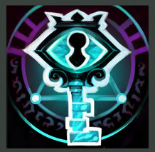

Ability Icon example

The world in side this Trap is one of complete mystery to the player and the character. The Narative starts out 3D, but inside this world is a 2D existence – the 3rd dimension is a mystery. This world draws heavily on the ideas of Flatland (<https://en.wikipedia.org/wiki/Flatland>) and how there are various shapes that might have more power as NPCs, thought here are also ‘People’ stuck in the trap world as well.

Ultimate abilities later in the game will make use of the ability to ‘exit’ flatland, bypassing some obstacles and making light work of others

**Game Experience:** After the Capstone Games Logo, first time players will be put directly into the cutscene and story exposition of Whisper entering the mine and falling into the trapworld. It will be told through detailed still images with some slight moving pieces, possibly in a detailed pixel art. It will then go through the introduction of the basic controls (Rotate CW/CCW) and have players help whisper out of a simple 2 shape puzzle.

After Whisper is freed from the first trap, players will enter their username, and be asked if they want to create an account for competitive leaderboard purposes (Exiting a level in the least amount of turns) The background will show the now 2D figure of Whisper hanging out in the Town area between traps, and give the general menu – options, leaderboards, continue, daily challenges

While some nice 2D sprites will be used for Whisper, and for various NPCs, many of the natural denizines of the world will be far more like ‘West of Loathing’ characters in 2D stick figure or geometric shape mannerisms than nicer pixel sprites.

Everytime Whisper is freed from inside one set of shapes, he’ll find himself in the safe town. Mostly populated by Flatlanders, it is also where other 3D people now trapped as 2D sprites will congregate as Whisper helps them out of the puzzles they are trapped inside. They can help Whisper by giving him new powers, and each of them has several conversation trees to follow based on what powers Whisper has obtained and what puzzle level he has completed.

One of them may even be the originator of this strange world…

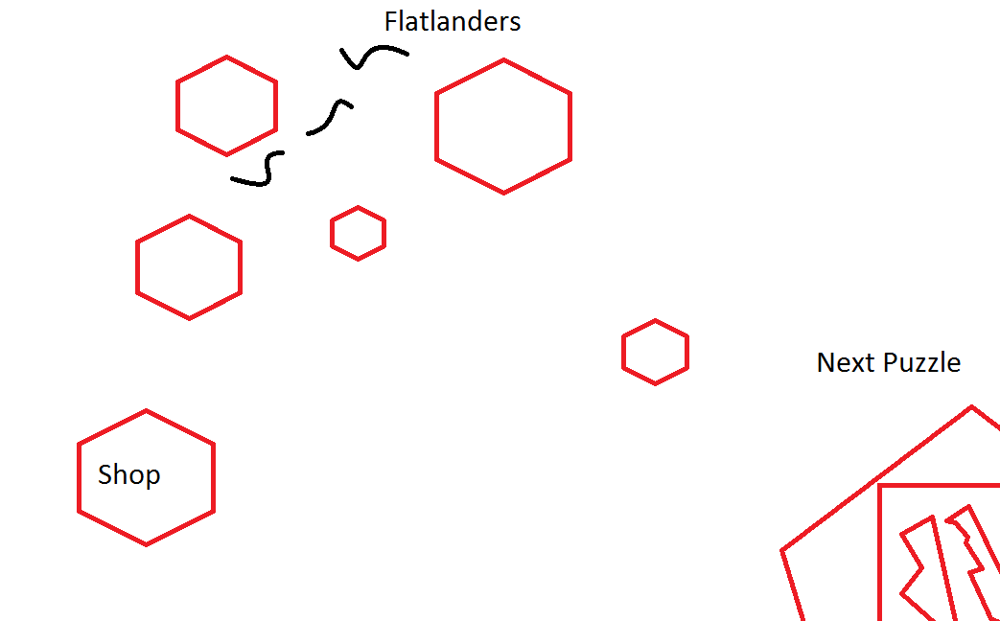

**Gameplay Mechanics** These are some of the puzzles that Whisper will have to pass.

**Hazards:** These bits make up the various puzzles that will have to be passed. They all react to being rotated in various ways

**Pits**: Various dead ends within the puzzle shapes. At first that means that whisper will have to go the other direction to get around them. Eventually, abilities will help (and be absolutely necessary) to get past them. Falling in one means rotating the world so it can be escaped

**Locks:** Various locks that need either a key or a button to be opened. Most of the time these locks will prevent access to a further shape or prevent liquids from moving and falling out of the area. Some of these doors will open if they are a certain direction in the game world, and can be locked open if done right them. Others will simply need to be opened to work at all.

**Liquids:** Liquids, such as water (Simply impassable) or Laval (May destroy certain parts of the shapes) that will have to be removed or bypassed. They follow ‘gravity’ and will fall as the world is rotated.

**Flatlanders:** Some flatlanders don’t like having Whisper and his kind here. While there is no combat, they will have to be dealt with. Encountering them directly they trap Whisper and send him back to the starting point of the puzzle. They will have to be avoided or locked away. Flatlanders will ignore the rotation of the world, and gravity – there is no ‘up or down’ in flatland.

**Gravity Change:** What direction is ‘down’ is mutable in flatland. Getting past some obstacles will mean changing that so that Whisper instead walks on the outside of a shape instead of the inside, or vise versa. It will also affect some flatlanders, liquid, locks, and pits.

**Abilities:** These are some of the abilities Whisper will learn from rescued NPC, non Flatlanders

**Jump:** the concept of jumping is foreign to Flatlanders – there is no up or down. Because Whisper and the 3Ders still have an understanding of that concept they can sometimes use it to bypass pits and other obstacles by jumping when the world rotates.

**Gravity Change:** Most of the time the gravity change will have to be done by a button found in the world (Who placed these here is part of the mystery). Eventually, Whisper will learn the ability to change gravity on his own, and can make use of it whenever it is necessary.

**Dash:** Sometimes, you just have to go fast.

**World Shake:** Spin all the shapes into a new configuration. This can only be used once per puzzle. Sometimes used to get past a situation. Sometimes used to make the puzzle harder. Can only be done in the center or outside of the puzzle.

**3D Phase** After rescuing a few more advanced NPCs, Whisper will realize there are some ways to phase into the 3rd dimension, allowing him to step ‘over’ certain parts. Can only be used at certain key points in the puzzle.

**Grappling Hook:** Everyone needs a grappling hook. An advanced form of jump, will allow for swinging across areas or reaching hard to reach areas.

**Enemies:** For the most part, the enemies are the environment. Various Flatlanders wander the shapes as well and must be dealt with.

**Squiggles:** Of the Line Cast, the Squiggle is a S shaped line that patrols an area. They will surround Whisper if they run into him, and bounce their way through the puzzle back to the starting point. They patrol in a set motion, and can be either avoided, locked away using doors, or trapped in pits.

**Squares:** Of the Shape Cast, the Square acts as a blocker. It can be moved, but only if a specific action is done for it first. It must be communicated with, in which it will tell Whisper ‘Remove the water’ or ‘Close those three doors’ before it will move out of his path.

**Circles:** The highest of the Shape Cast, Circles roll around as the world rotates, seemingly ignoring gravity – but obviously having indication that there is another dimension. They are silent about that fact however. To deal with them they must be trapped. If they encounter Whisper they usually only block his path.

**Bosses:**  Bosses are in the shape of sentient puzzles. Certain puzzles are alive in this world, having grown powerful enough to become aware of their existence, and not liking that Whisper is going into them at all.

**King Circle**: A Set of concentric circles filled with various liquids. There are only a few openings, but none big enough for Whisper to get through. IN order to get out, Whisper must combine the various colored liquids, creating explosions that rupture King Circle and allow Whisper to escape:.

**Emperor Dot**: A refuguee from 1D Land, Emperor Dot wants nothing to do with anything that is not himself – he is all, singular and only, and does not admit the existance of anything around him. Emperor Dot is a boss because he is trapped in a series of shapes. Everytime he encounters Whisper he tells him (by speaking to himself, as only Emperor Dot exists) that he is going mad, and then shrinks the world to the size of a dot. When it returns, Whisper has returned to the starting point. Emperor Dot must be dealt with by closing a series of doors so that he can never be in the same space as Whisper

**Sphere:** Sphere is a shape from 3D land, though how it has sentience is anyoens guess. It can change its size, becoming bigger or smaller as it passes /through/ Flatland. The Sphere boss dungeon changes size with every rotation, causing some areas to open or close, liquids to take up more space, ect.

**Mirror:** Mirror is a dungeon that must be taken on by triggering special effects that flip the dungeon across its axis, either horizontally or vertically. This effect confuses the flatlanders, who simply see things disappearing and reappearing backwards on the other side. Using the concept of the flip, Mirror can be dealt with.

**Cutscenes:** Most of the story will be told through cutscenes and dialogue choices. There is the initial cutscene where Whisper enters the mine and is trapped, as well as a cutscene for each ‘Boss’ puzzle with special mechanics. These cutscenes will introduce the boss, its special mechanic, and have the boss speak with Whisper about the world and how crazy these 3D shapes look to them.

**Bonus Material:** Soundtrack will be made available, Jean Marqs great music for all to hear.

Additionally, after release, weekly puzzles will be made available for continued play that have little to do with the story line.

After completing the game for the first time, several of the NPCs open up to be playable characters to attempt the game a second time. They differ in their dialogue options, as well as not having the Jump power. Instead, they receive a different power that will get them across the areas jumping is required. A short-range teleport that can access some areas that Whisper could not, finding secrets. Building a line (with a pen) that can be crossed, or block off enemies. Or other abilities.

Additional characters will be released as DLC, with new abilities and storylines of their own. Additional Boss Puzzles will be included for each DLC character, which can also be played with the standard set.

**Monetization:**

Everboxing will be sold as a single unit game, for 9.99 or 14.99 depending on market research into similar products. It will be sold on Steam and GoG, in a DRM free version direct from publisher.

DLC will be sold at a price of 2.99 or 4.99, depending on market research into similar products.

The sound track will be based on market research as well.

No in game currency will be utilized.